Phonetics
- [ ɔː] Sports report from Radio Station 4. (Ship or sheep p35)
- [ aɪ ] Heidi, Caroline, Nigel . (Ship or sheep p59)

Grammar
- Speak about the Present Simple, give examples.
  - How is it formed? (+, -, ?, Who?)
  - When is it used?
  - What are the spelling and pronunciation rules?
  - What time expressions are used with the tense?
- Speak about adverbs of frequency, give examples.
  - Name the adverbs
  - What grammar tense needs the adverbs?
  - Where are they put in a sentence?
- Speak about the Present Continuous, give examples.
  - How is it formed? (+, -, ?, Who?)
  - When is it used?
  - What are the spelling rules?
  - What time expressions are used with the tense?
  - What verbs are not used in the Present Continuous?
- Speak about the difference between the Present Simple and Continuous, give examples.
- Time
- Speak about the Future Simple, give examples.
  - How is it formed? (+, -, ?, Who?)
  - When is it used?
  - What time expressions are used with the tense?
- Speak about be going to, give examples.
  - How is it formed? (+, -, ?, Who?)
  - When is it used?
- Speak about the Present Continuous (future meaning), give examples.
  - How is it formed? (+, -, ?, Who?)
  - When is it used?
- What grammar structures/ tenses are used to express future?
  - When is be going to used?
  - When is the Future Simple used?
  - When is the Present Continuous used?
  - Give examples.

Dialogues: SB p 15 dial A-B-C, WB p31 ex 15 Making a complaint
Text: At Kendal Camp
Vocabulary: Unit 5, 1
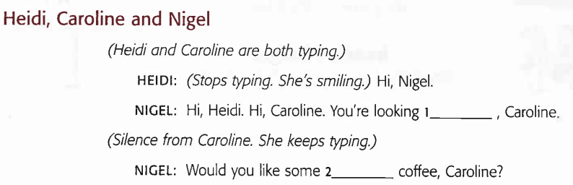
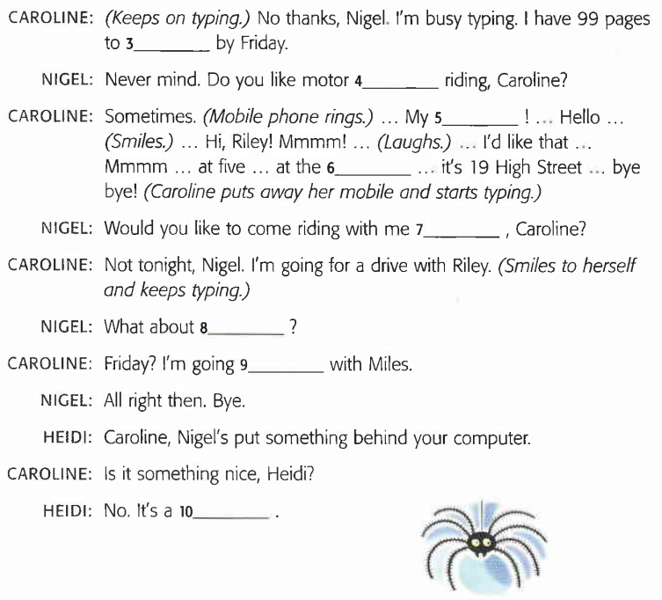
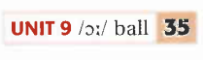
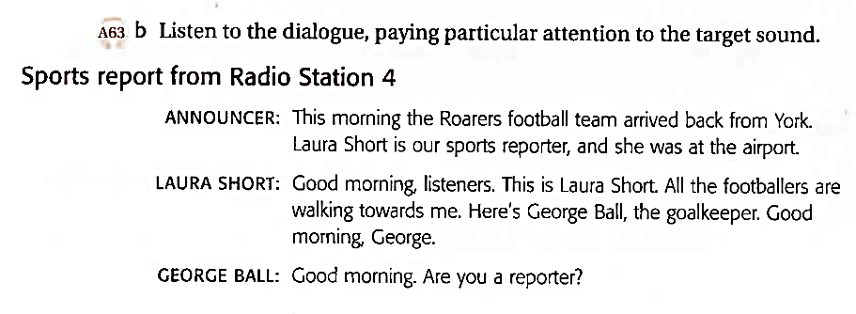
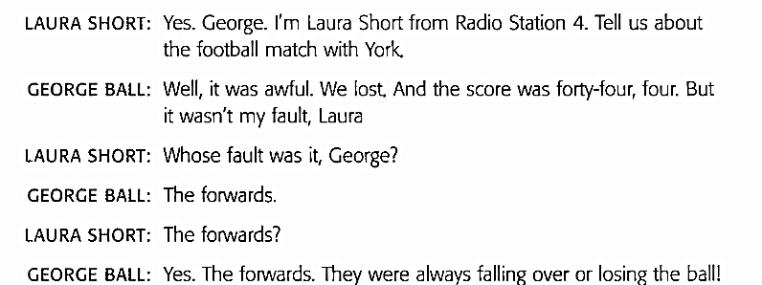

Speak about the Present Simple, give examples.
- How is it formed? (+, -, ?, Who?)
- When is it used?
- What are the spelling and pronunciation rules?
- What time expressions are used with the tense?

Construction | + V₁/V_{s}  - don’t/doesn’t + V₁  ? ?word + do/does + S + V₁  Who + V_{s} ?
Spelling rules | - verbs ending in –s, -ss, sh-, -ch, -x, -o + es  - verbs ending in a consonant + y = ies  - verbs ending in a vowel +y take s
Pronunciation | s/es is pronounced:  - /s/ with verbs ending in /f/, /k/, /p/, /t/  - /ɪz/ with verbs ending in /s/, /z/, /ʃ/, /tʃ/, /dʒ/  - /z/ with verbs ending in all other sounds
Used for | - daily routines  - repeated actions  - habits  - permanent states
Time expressions | - every day/hour/week, etc  - adverbs of frequency  - in the morning/afternoon, etc.  - at night/noon

Speak about the Present Continuous, give examples.
- How is it formed? (+, -, ?, Who?)
- When is it used?
- What are the spelling rules?
- What time expressions are used with the tense?
- What verbs are not used in the Present Continuous?

Construction | + to be + V_{ing}  - to be + not + V_{ing}?  ? ?word + to be + S + V_{ing}  Who + is + V_{ing} ?  Verbs that don’t have a continuous form:  have (=possess), love, like, hate, want, know, remember, understand, forget, think, believe, cost.
Spelling rules | - verbs ending in –e drop the -e and add -ing  - verbs ending in a vowel + a consonant, double the consonant and add -ing
Used for | - actions happening now, at the moment of speaking  - actions happening around the moment of speaking  - temporary situations  - fixed arrangements in the near future, especially when we know the time and the place
Time expressions | now, at the moment, at present, these days, tomorrow, next week, in a week, etc.

Speak about the difference between the Present Simple and Continuous, give examples.

Present Simple is used for | Present Continuous is used for
- daily routines  - repeated actions  - habits  - permanent states | - actions happening now, at the moment of speaking  - actions happening around the moment of speaking  - temporary situations  - fixed arrangements in the near future, especially when we know the time and the place

Speak about adverbs of frequency.
- Name the adverbs
- What grammar tense needs the adverbs?
- Where are they put in a sentence?
- Give examples

Adverbs of frequency tell us how often something happens. We use them with the present simple. We use them before the main verb but after auxiliary verbs.
They are: always (100%), usually (75%), often (50%), sometimes (25%), seldom/rarely (10%), never (0%).

Speak about agreeing/ disagreeing, give examples.
- How do we agree with affirmative/ negative statements?
- How do we disagree with affirmative/ negative statements?

 | Agreeing | Disagreeing
Affirmative | So + auxiliary + S | Oh! Really? S + negative auxiliary
Negative | Neither + auxiliary + S | Oh! Really? S + auxiliary

Speak about prepositions at, in, on
- as prepositions of time.
- What expressions (besides expressions of time) are the prepositions used in?
- Give examples

At/ in/ on used as prepositions of time

AT | time | at 7 o’clock
 | holidays | at Easter
 | expressions | at noon/midday/midnight/daybreak/the moment/the weekend/night
IN | months | in May
 | seasons | in the spring
 | years | in 2013
 | expressions | in the afternoon/evening/morning
ON | days | on Monday
 | dates | on 2May

What grammar structures/ tenses are used to express future?
- When is be going to used?
- When is the Future Simple used?
- When is the Present Continuous used?

 | be going to | Future Simple | Present Continuous
Structure | + be + going to + V₁  - be+not+going to+V₁  ? ?w+be+S+going to+ V₁  Who is going to V₁? | + will + V₁  - won’t + V₁  ? ? word +will +S + V₁  Who will + V₁? | + to be + V_{ing}  - to be + not + V_{ing}?  ? ?_{word} + to be+S +V_{ing}  Who + is + V_{ing} ?
Used for | - plans  - intentions  - predictions based on what you see | - predictions based on what we think/believe  - promises/threats  - on-the-spot decisions  - with think, believe, expect, probably, hope, imagine, perhaps | - fixed arrangements in the near future
Expressions |  | tomorrow, soon, next week/month, the day after tomorrow, tonight, in a week/month

At Kendal Camp

Hello. I'm Laura. Laura Newton. I'm a student at St George's, but I have a part-time job at weekends. I work in a supermarket and I don't really mind working on Saturdays.
It's my first time at Kendal Camp. It's so nice here in summer. The birds are singing. The wind is blowing. The children are swimming and laughing. A dog is barking. The ducks are quacking. The radio is playing. A helicopter is flying over the camp.
I'm looking for the Art room. I've already introduced myself to some of the students and teachers here. Do you see that man? The one who is drinking cola. That's Bill. He's the Art teacher. And that woman with him is Anita. She's from Brazil and she's the Drama teacher. Some people in the camp are very important. Mary is an accountant and a secretary. She keeps financial accounts, types letters and answers the phone for the camp head teacher.
Those two students over there are my new friends, Steve and Kate. They are waiting for Alan, who is flying the camp helicopter at the moment. They are going sailing later. How exciting! I'm going horse-riding after my Art class. Fancy joining me?
It's a seaside camp and there are mountains here, too. I'm really lucky, because there is plenty to see and do. One can go climbing in the morning. You can go snorkelling, scuba diving, canoeing or water-skiing in the afternoon. If you don't enjoy water sports, you can read books, cycle or even do some gardening or cut the grass. Paula, the gardener, is very nice, she looks after plants. Costas always helps her. He is from Greece. He protects the camp, because he is a security guard.
I'm good at ice-skating, but there's no skating rink. There are no shops. This is good, because I hate shopping. There's a computer room where you can surf the net and write home. Boys often join Mike. He is a carpenter. He teaches boys to make wooden furniture. Girls sometimes help Lisa. She is a vet and looks after sick animals.
I really like the camp and so do all the children.

